Google E hackathon 2024 Prep

Main website link: Google Cloud x Formula E AI Hackathon (inthecloud.withgoogle.com)

To access a public 'star' project in BIGQUERY console do the following:

In the BIGQUERY console in Google Cloud Console (note you probably don't need to do this if you're accessing bigquery via an api in VERTICA workbench)

Uploading queryable data
In this section you pull in some public data into your project so you can practice running SQL commands in BigQuery.
- Click on + ADD.
- Choose Star a project by name.
- Enter project name as bigquery-public-data.
- Click STAR.

Before going to VERTEX WORKBENCH and creating a JUPYTERLAB In Google Console search for VERTEX AI and make sure you enable all VERTEX APIs:

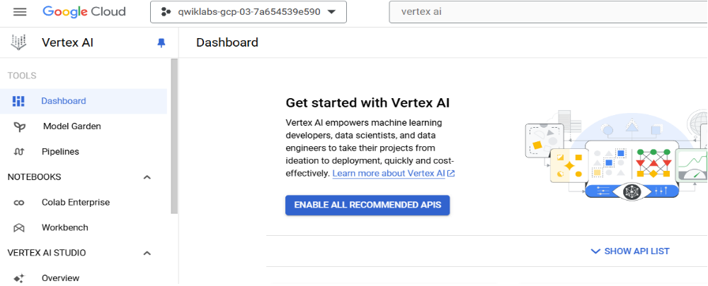

Launch Vertex AI Notebooks – what you really need to access in order to create a JupyterLab vm within which to create Jupyter notebooks (ipynb) or a python application (py) is VERTICA AI WORKBENCH.
- In the Cloud Console, in the Search field, type "vertex", then click Vertex AI in the results.
- From the left menu click on Workbench.
- Click the Enable Notebooks API button.
- At the top of the Workbench page, click + Create New.
- In the pop-up, choose a name for your notebook. For Region, select <filled in at lab start> and for Zone, select a zone within that region.
- For Environment, select "Python 3 (with Intel® MKL)"
- Leave the remaining fields with their default and click Create.
- Click Open JupyterLab. A JupyterLab window will open in a new tab.

When you click a new tab with the JupyterLab VM will open, in the create new dropdown you need to choose to create a python file (application) – note it is important at this stage to create your python file as an application or you will not be able to deploy it (as a streamlit app for example), note you might need to run a IPYNB notebook in parallel in order to test the code in your .py application.

Basic Script Integrating BIGQUERY with python (in vertex ai workbench/jupyter lab)

# following code imports the BigQuery Python Client Library and initializes a client.
# The BigQuery client will be used to send and receive messages from the BigQuery API.
from google.cloud import bigquery
client = bigquery.Client()

sql = """
SELECT start_station_name, COUNT(*) AS num FROM
`bigquery-public-data.london_bicycles.cycle_hire` GROUP BY start_station_name ORDER BY start_station_name;
"""
df = client.query(sql).to_dataframe()
df.head()

link to Kaggle 'formulaE' dataset:

Starter: Formula E Championship 1434487f-e (kaggle.com)

